68)

1)here see use of margin:auto, to align the block element in middle.

<https://stackoverflow.com/questions/4955122/what-exactly-is-needed-for-margin-0-auto-to-work/4955135#4955135>

2)see these questions about text align-

<https://www.udemy.com/css-the-complete-guide-incl-flexbox-grid-sass/learn/v4/questions/5859524>

<https://www.udemy.com/css-the-complete-guide-incl-flexbox-grid-sass/learn/v4/questions/6128240>

these 2 questions explain that text-align is used to center inline or inline-block elements inside block element. And text-align property is inherited.

73)styling links

<https://www.udemy.com/css-the-complete-guide-incl-flexbox-grid-sass/learn/lecture/9474944#questions/7822972>

<https://www.udemy.com/css-the-complete-guide-incl-flexbox-grid-sass/learn/lecture/9474944#questions/7823492>

<https://www.udemy.com/css-the-complete-guide-incl-flexbox-grid-sass/learn/lecture/9474944#questions/7822972>

75)Adding “float” to our package

Here we saw how float and clear work.

See these videos for detail-

<https://www.youtube.com/watch?v=xara4Z1b18I>

<https://www.youtube.com/watch?v=gMuqxtG_5Xc> (see this)(clear is wrong here)

inline content always wraps itself around floated element—remember this

<https://www.youtube.com/watch?v=LrdkRMZhgZg>

<https://www.youtube.com/watch?v=P4x9GyqBWE0> (see from 04:20)

in video 2 and video3 see how clear, behaves in case of floated or non floated elements.

In video 4 see how you can floated elements in container.

Meaning of clear property-

**By assigning a clear: left property value to our green block, we’ve told it to act as if the pink block is in the normal flow of our document, even though it has been removed, and to sit below it. This is an immensely powerful property; as you can see, it helps bring our non-floated elements back into the normal flow, a behavior that we tend to expect by default. That said, knowing and understanding both the float and clearproperty really starts to open some creative doors when you write your HTML and CSS.**

article where this is described-

<https://alistapart.com/article/css-floats-101>

another article-

<https://www.hongkiat.com/blog/css-floats/> (Informative)

height rule-

<https://designshack.net/articles/css/everything-you-never-knew-about-css-floats/>

see mdn Mozilla box-

here is what happens to example on Mozilla, when we give boder to p tag-

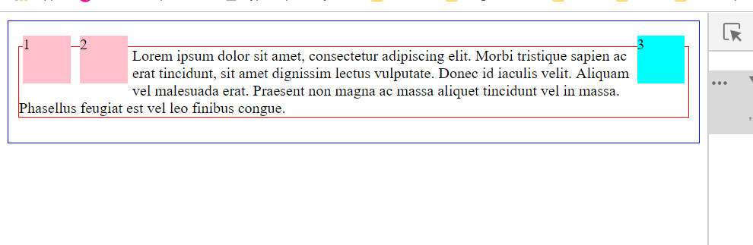

Here see the use of margin-left-

<https://www.udemy.com/css-the-complete-guide-incl-flexbox-grid-sass/learn/v4/questions/3938682>

question-

<https://www.udemy.com/css-the-complete-guide-incl-flexbox-grid-sass/learn/v4/questions/6410324>

76)fixing the hover effect

See lecture.

Here is question about box-shadow not applied to free section-

<https://www.udemy.com/css-the-complete-guide-incl-flexbox-grid-sass/learn/v4/questions/6410524>